Cost-Effective Reverse Vending Machine Project
Fazil Onuralp Ardic - Lutfi Eren Erdogan - Onur Yavuz
What is a Reverse Vending Machine and What Are Their Uses?
A reverse vending machine is a device that accepts beverage containers and gives a reward (usually money) in return to the user. They are used in various countries such as Greece, Japan, South Korea, the U.S, China, and Europe as a method of incentivizing recycling.
How Did We Start?
Seeing reverse vending machines as commonplace in German and Swedish supermarkets, we wanted to deploy these machines in Turkish stores. For this, we initiated a project under our school’s WWF Club.
We contacted Migros, a large supermarket chain in Turkey, and proposed bringing reverse vending machines to their stores. After talking with Cansu Ergün, the Sustainability Manager at Migros, we learned that they had already contacted international and local firms and encountered three red flags: the machines were bulky, expensive, and prone to fraud.
After receiving this information, the project turned into an independent initiative. It evolved from acting as an intermediate between firms to active development where we designed and built the machine ourselves.
In UOMO Bootcamp Startup Competition, our project was selected by a jury of angel investors as the winner and received 2000 TL. It also won the “Most Promising Project” Award in WWF Environmental Pioneers Youth Program.
The Aim of this Project
Our aim is to build a compact, cost-effective, and fraud-resistant reverse vending machine using minimalistic design. After 2021, our government will enact a container deposit legislation that will put monetary deposits on plastic, metal, glass, and carton containers. With this legislation, reverse vending machines will be ever more important and prevalent.
We decided to place the first prototype in our school for testing after talking with Nichole Chartier, one of the deans in our school. Currently, we have built the prototype of the machine and are gathering data to improve our AI (container classifier) system.
Our long-term goal is to deploy these machines in Migros or other supermarket chains. This project is also being monitored by WWF Turkey which might provide other alternative places of deployment.
Our Design
Our reverse vending machine uses AI-powered computer vision and a load cell to sort the containers. The computer vision algorithm classifies the containers into three categories (metal, plastic and carton) and the load cell checks whether they contain liquid or not. After accepting the containers, the machine transfers money to the user’s card. The 3D model of the machine was drawn using the Onshape computer-aided design software and all parts/section views/measurements can be found in the link below: https://cad.onshape.com/documents/95441ff1379403982ee48918/w/f8e7588caed9ca65084a9f9a/e/798f00f1670b4d87b2a92338
Our code can be found in the GitHub repository below: https://github.com/xTRam1/Cost-Effective-Reverse-Vending-Machine-Project
*We have yet to place the exterior coating of the machine since it is easier to work with, so the photos below only show the interior mechanisms of the machine.
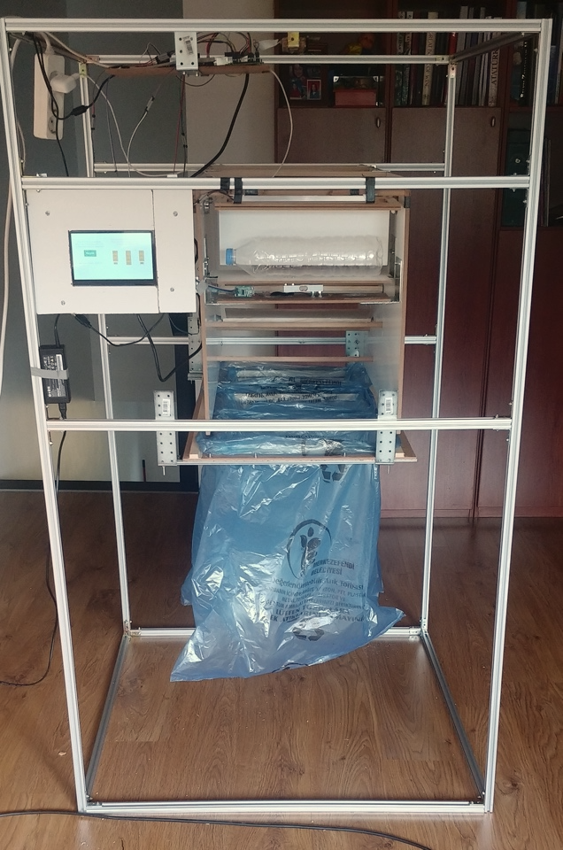
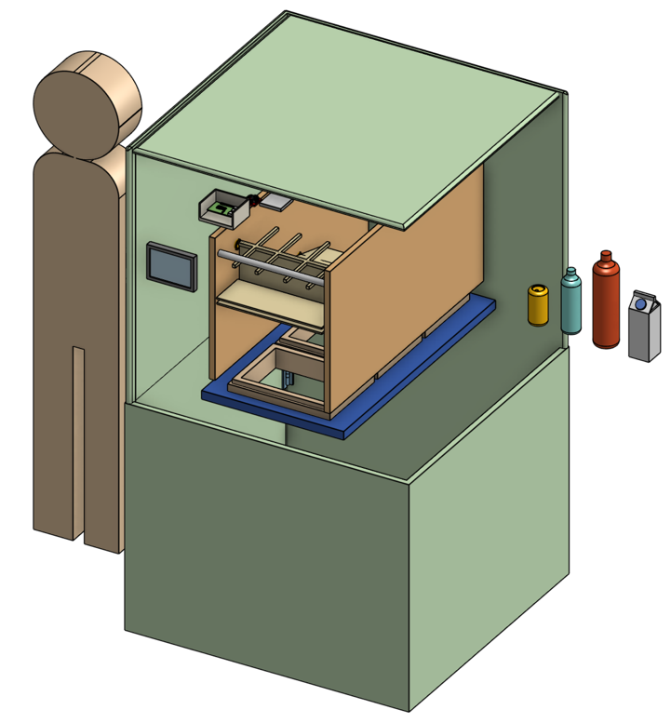
- The process starts with the user placing their container inside the machine.
From left to right:
330mL Can Container,
500mL Plastic Bottle,
1.5L Plastic Bottle,
1L Carton Container
Height of the reference human is 165cm, roughly the average height of a Turkish person.

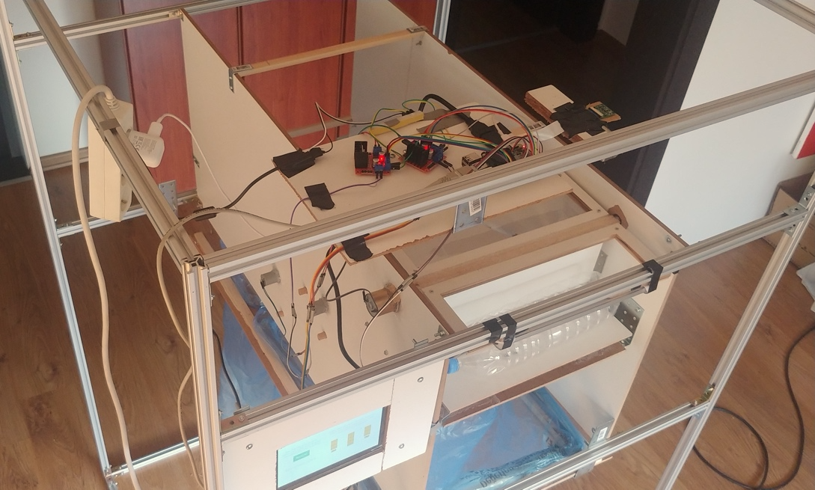
- Then the user presses the “Recycle” button on the touch screen. The camera takes a picture of the container and classifies it into one of the three categories (plastic, metal, carton) using the Computer Vision algorithm we coded. Simultaneously, the weight sensor takes a measurement and determines whether the container holds liquid or not. These processes are coordinated via Raspberry Pi 4 microcontroller.

L298N Motor Controllers
Camera
Raspberry Pi 4 Microcontroller

Motors
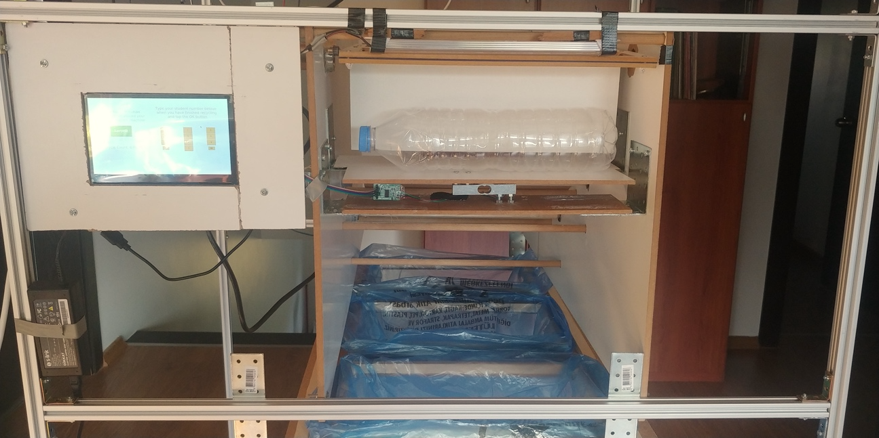
Graphical User Interface

Load Cell/Weight Sensor
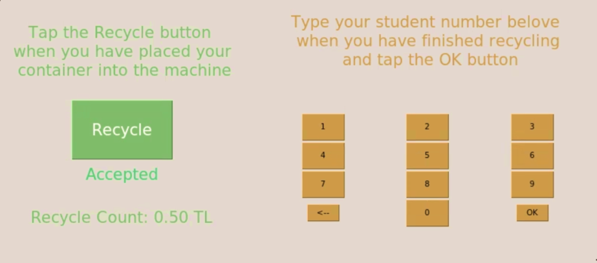
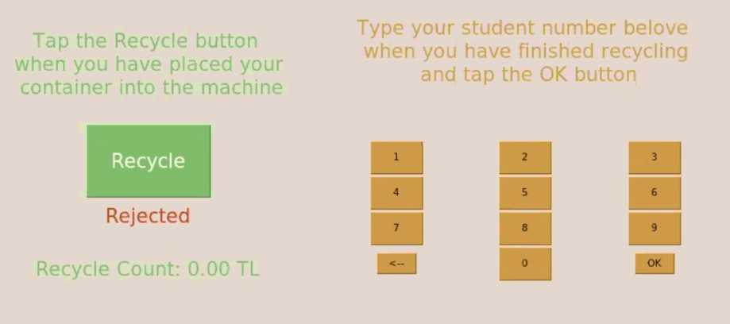
- If the container is accepted, a mechanism takes it inside the machine; if not, the machine tells the user to remove the container and repeat.

- Then the container goes down a ramp composed of 2 separators that direct the container to the correct storage unit (for the three types) according to the classification that the algorithm made.
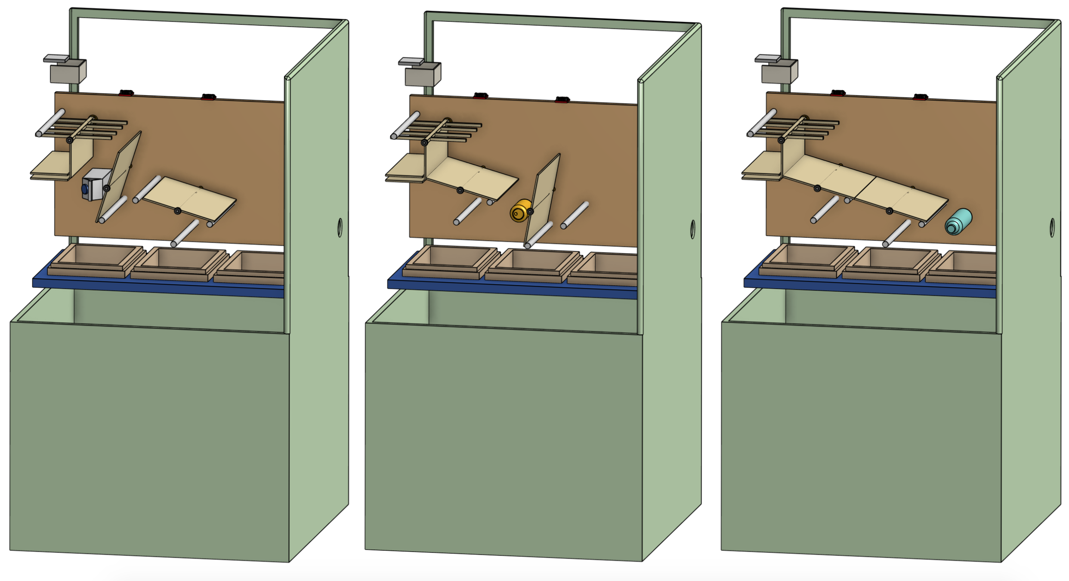
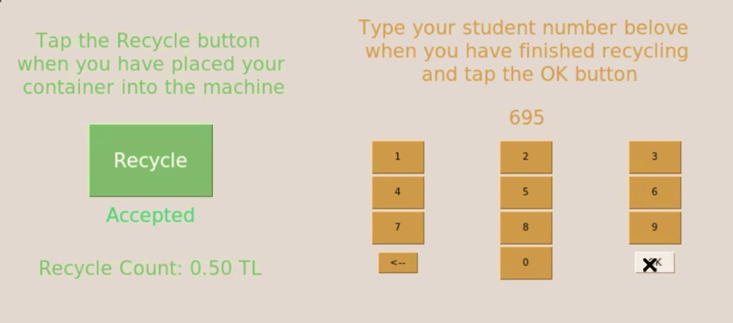
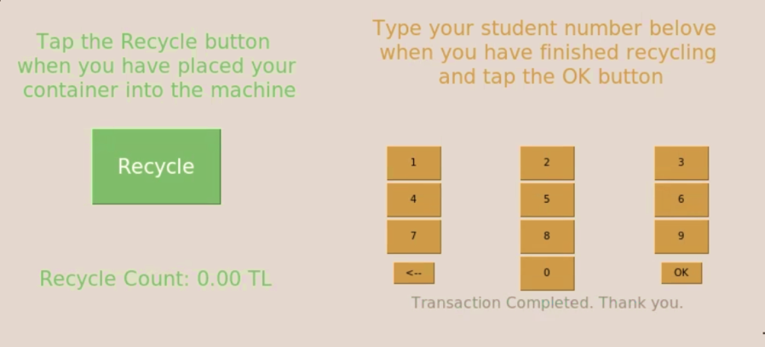
- The user is able to put as many containers as possible before pressing the “Done” button which directs the customer to a page where they are expected to type their school card number (for the model that will be used in our school). Once the students enter their school card number, the machine transfers the predetermined (by the deposit legislation) reward to the user’s card.

- Once the machine is full and gives a warning, it can be emptied via a drawer mechanism.
- In the future models, we plan to implement the option of not accepting the reward and sending it to a collective account where the ones in need can withdraw money from.
